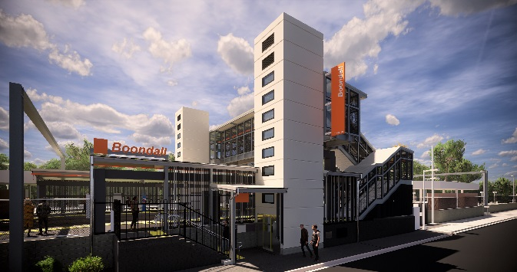
Boondall station accessibility upgrade

PROJECT UPDATE – OCTOBER 2019

The Boondall station accessibility upgrade is part of the State Government’s $357 million program to upgrade stations across the South East Queensland network, making them accessible for all customers.

Project progress
Activities undertaken recently at Boondall have included:
- installation of lighting and services in footbridge staircases
- installation of new ticket window
- ongoing platform works
- ongoing lift installation.

Upcoming works
In the coming weeks, customers and the community can expect to see the following activities:
- platform surface works and paving
- completion of new ticket window
- progression of platform paving works
- construction of western entry plaza and upgrade of footpath to platform 2 and lighting
- ongoing lift installation
- station entrance, kerbing and gutters (Aberdeen Parade).

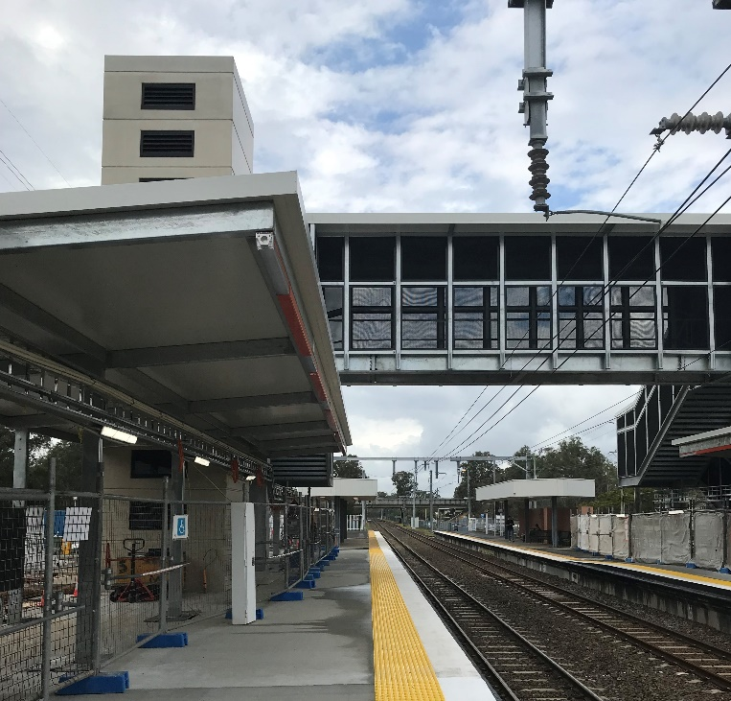
The station’s platforms will be closed for uninterrupted works from 11.30pm Friday 18 until 4am Monday 21 October. Rail services will not stop at Boondall during this time. Half-hourly shuttle bus services will take customers to North Boondall to connect with all services (allow an additional 30 minutes’ travel time).
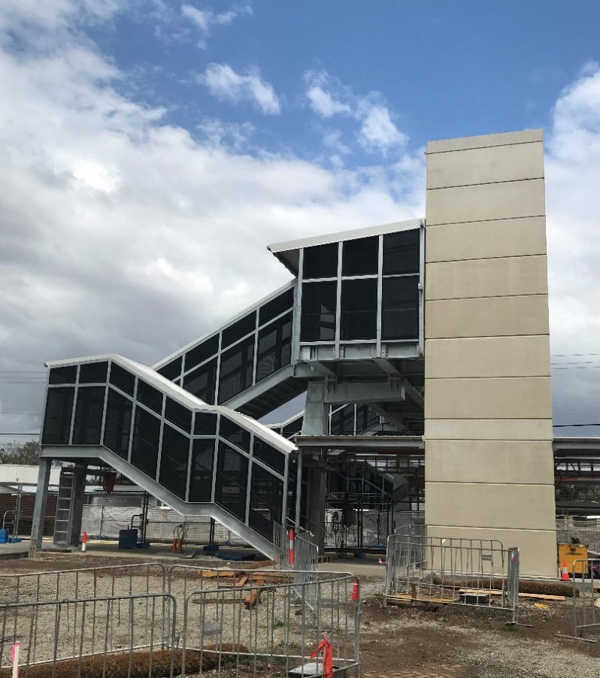

Construction impacts

Normal working hours are 6am to 5pm Monday to Saturday. Construction activities may involve:

noise associated with heavy machinery

temporary changes to station access paths

changed traffic/parking conditions (Aberdeen Parade)

increased vehicle movements near works

mobile lighting towers for night works.

Please take care around the work zones.

Local residents will be given advance notification of construction activities likely to cause impacts, including after hours work (nights and Sundays, as required).

We thank customers and the community for your patience and cooperation as we work to improve your station.

Contact us

For more information or to provide feedback:

Phone: 1800 722 203 (free call)

Email: stationsupgrade@qr.com.au

Website: queenslandrail.com.au

