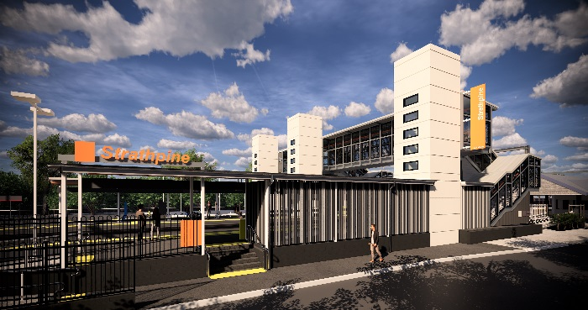
Strathpine station accessibility upgrade

PROJECT UPDATE – JANUARY 2019

The Strathpine station accessibility upgrade is part of Queensland Rail’s $300 million program to upgrade stations across the South East Queensland network, making them accessible for all customers.

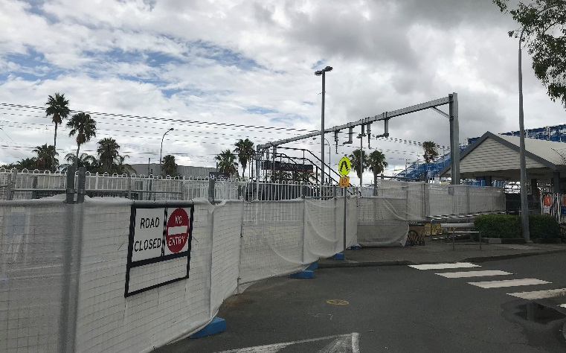
Works area for new footbridge and eastern entrance

Project progress
During December the following activities were undertaken at Strathpine:
- commencement of work on temporary construction access across the track
- demolition works on platform 2/3 – removal of main shelter (pictured below).

The ramp to platform 2/3 (at South Pine Road level crossing) is closed during construction. Please see station staff if you require assistance accessing the station or boarding services.
Upcoming works
This month, customers and the community can expect to see the following activities:
- completion of temporary construction access across track
- continued demolition works – remainder of original staircase bases
- commencement of excavation works for new footbridge.
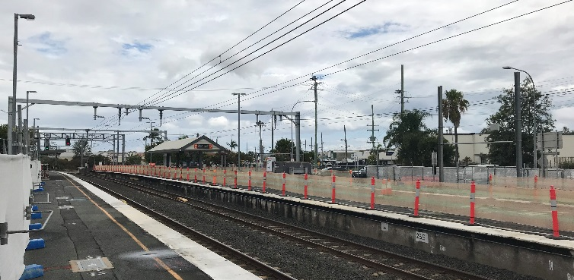
Shelter demolished for footbridge construction

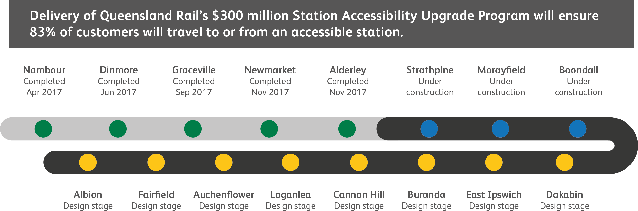

Construction impacts

Normal working hours are 6am to 5pm Monday to Saturday. Construction activities may involve:

noise associated with heavy machinery

temporary changes to access paths throughout the station precinct

changed traffic and parking conditions

increased vehicle movements near works

mobile lighting towers for night works.

Please follow all directional signage and take care around the work zones.

We thank customers and the community for your patience and cooperation as we work to improve your station.

Contact us

For more information or to provide feedback:

Phone: 1800 722 203 (free call)

Email: stationsupgrade@qr.com.au

Website: queenslandrail.com.au

