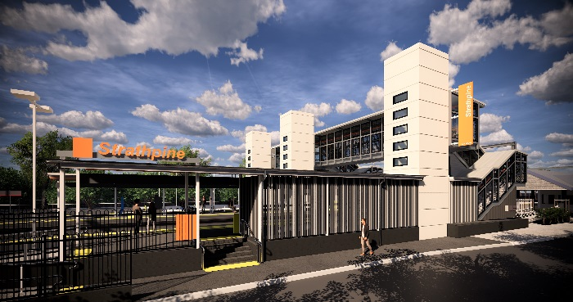
Strathpine station accessibility upgrade

PROJECT UPDATE – MARCH 2019

The Strathpine station accessibility upgrade is part of Queensland Rail’s $300 million program to upgrade stations across the South East Queensland network, making them accessible for all customers.

Project progress
In February, the following activities were undertaken at Strathpine:
- major piling (foundation) works for new lift shaft (western carpark)
- excavations and screw piling for foundations for raised section of platform 1
- preparatory excavations to platform 2/3
- service conduit relocations – platform 1.

Upcoming works
This month, customers and the community can expect to see the following activities:
- lift shaft walls (formwork, reinforcement and concrete) – platform 1 and western carpark
- screw piling for footbridge and lift shaft foundations/footings – platform 2/3
- pour concrete for raised section – platform 1.
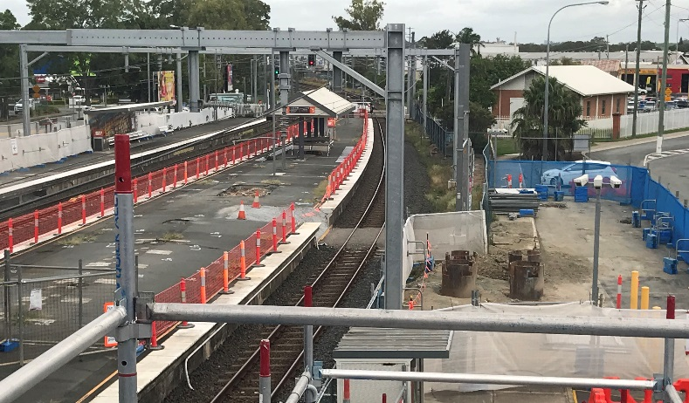

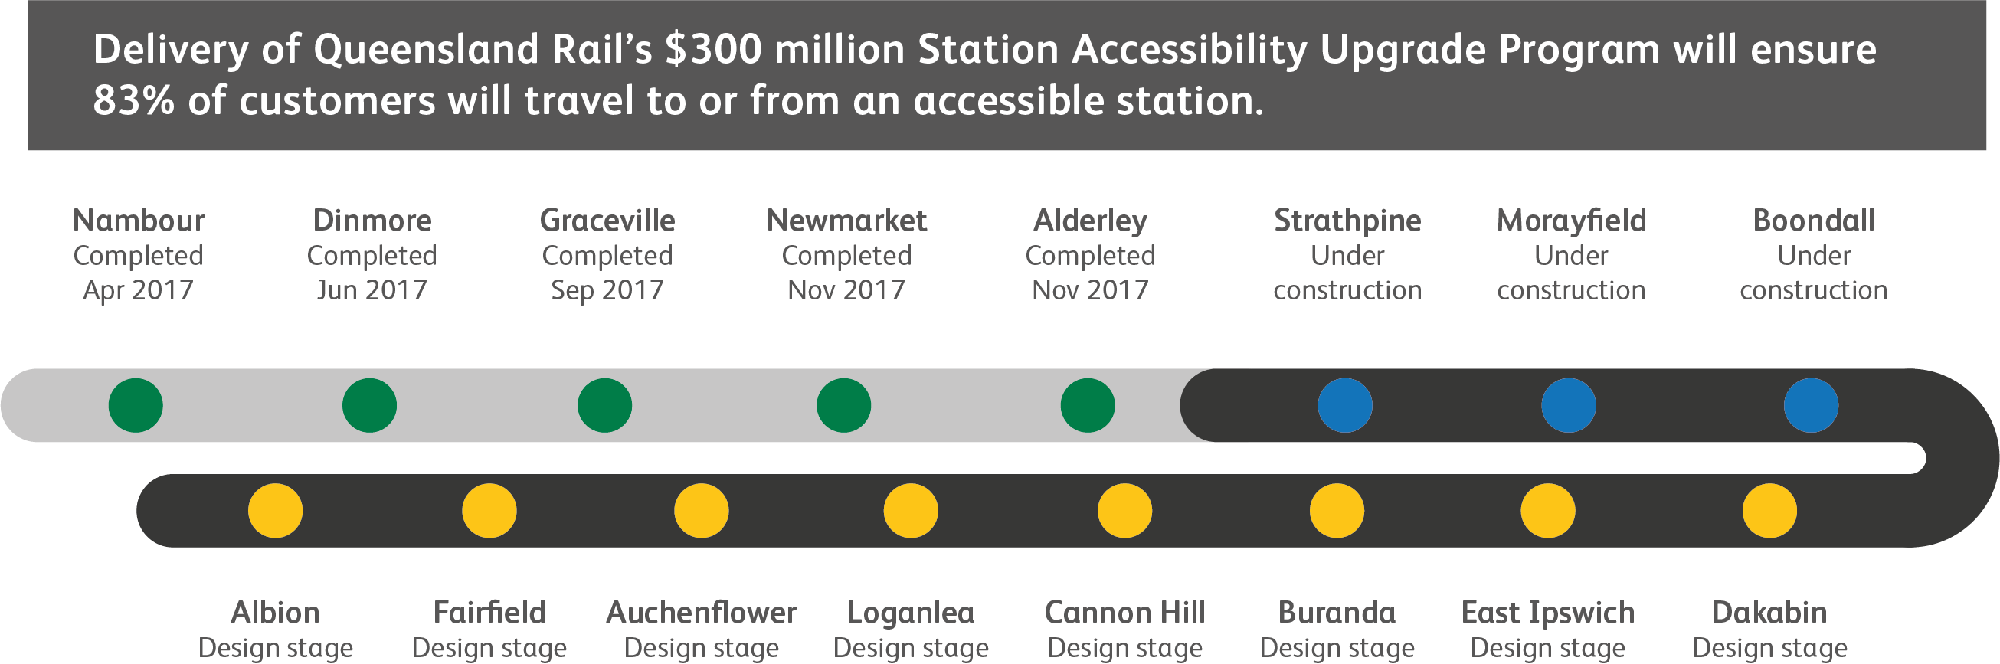

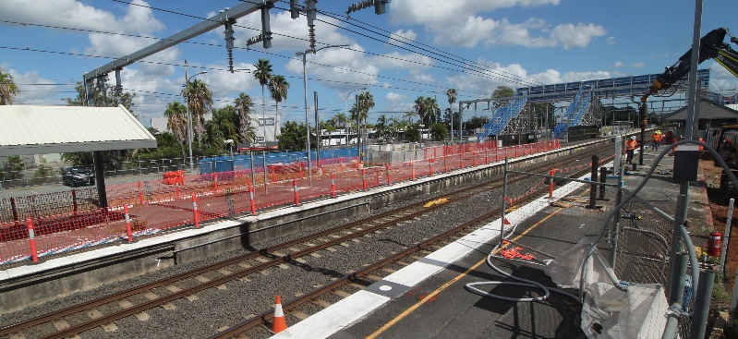

Construction impacts

Normal working hours are 6am to 5pm Monday to Saturday. Construction activities may involve:

noise associated with heavy machinery

temporary changes to access paths throughout the station precinct

ramp access to platform 2/3 (at level crossing) closed throughout construction

changed traffic and parking conditions

increased vehicle movements near works

mobile lighting towers for night works.

Please follow all directional signage and take care around the work zones.

We thank customers and the community for your patience and cooperation as we work to improve your station.

Contact us

For more information or to provide feedback:

Phone: 1800 722 203 (free call)

Email: stationsupgrade@qr.com.au

Website: queenslandrail.com.au

