Northgate QPS outpost project

PROJECT UPDATE – DECEMBER 2018

Queensland Rail is investing $1.9 million in the construction of a new Queensland Police Service (QPS) outpost at Northgate station to enhance security on the inner northern lines.

Work is progressing on the construction of the new QPS outpost at Northgate station, and we thank you for your cooperation during this time.

Project progress
The following construction activities were recently completed:
- site establishment
- foundation excavations
- concrete slabs poured
- wall panels lifted in.

Upcoming work
In the coming weeks, customers and members of the local community will see the following activities:
- installation of steel frames, roof and remaining walls
- internal building works
- installation of lighting and electrical services
- installation of signage
- reconfiguration of the carpark.

Construction impacts
Customers and residents near the work site will continue to experience a similar level of impact, including:
- noise associated with construction activities
- changed parking conditions
- temporary changes to access paths.
The new police outpost will be staffed by eight officers, who will work with officers based at Petrie station to respond to crime incidents across the northern lines.
It will help reduce the risk of crime on the northern Citytrain network through a heightened police presence.
The new outpost is expected to be completed in early 2019.
We will keep local residents, customers and community groups informed of our progress.
Thank you for your patience as we work to improve the safety of your network.
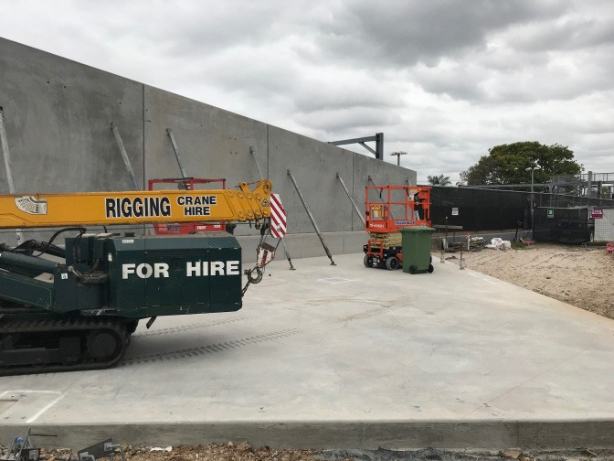

Further information
Phone: 13 16 17 (business hours) Email: customerfeedback@qr.com.au

Post: GPO Box 1429, Brisbane, QLD 4000
Website: queenslandrail.com.au

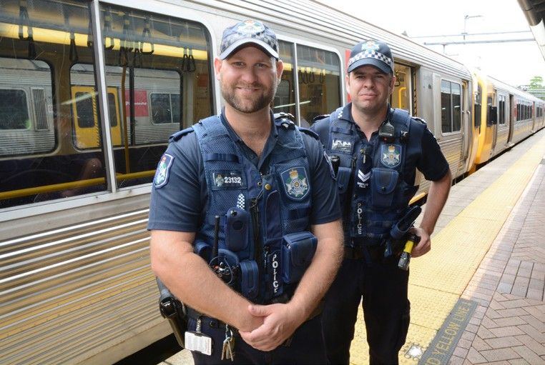
Queensland Rail Limited ABN 71 132 181 090 QR2018

